# Project Two

## About the Project/Project Title

The purpose of this project is to produce functions that can be used in mongo. Through these fuction’s the Grazioso’s dashboard can be used to obtain a detailed list of animals needed for search and recue missions.

## Motivation

The motivation for creating python code for databases is for accessing databases, collections, and documents. Creating python functions can cut down on code. The dash is used to put these fuctions to work. The dashboard was created to filter results as well as give location via the map. Also a chart was used to provide the percentage of animals available.

## Getting Started

To get started I begin by logging into mongo dBs then I opened up the jupyter notebook and created a new folder. Once I created a new folder I created a lib.py file, animal_shulter file and test_script, and ipynb file. The animal file is where the classes are defined. The test.py and the test.ipynb is where the functions can be tested.

## Installation

The tools needed is mongo db. and jupyter notebook.

**Tools used to achieve this functionality**

Jupyter Dash was used to create the dash with the AAC Database. Once the database was imported from mongo to jupyter dash I was able use the read function to bring in the information and incorporate it into a datatable. With the use Radio buttons they are able to filter animals according to pacific breeds, ages, and sex.

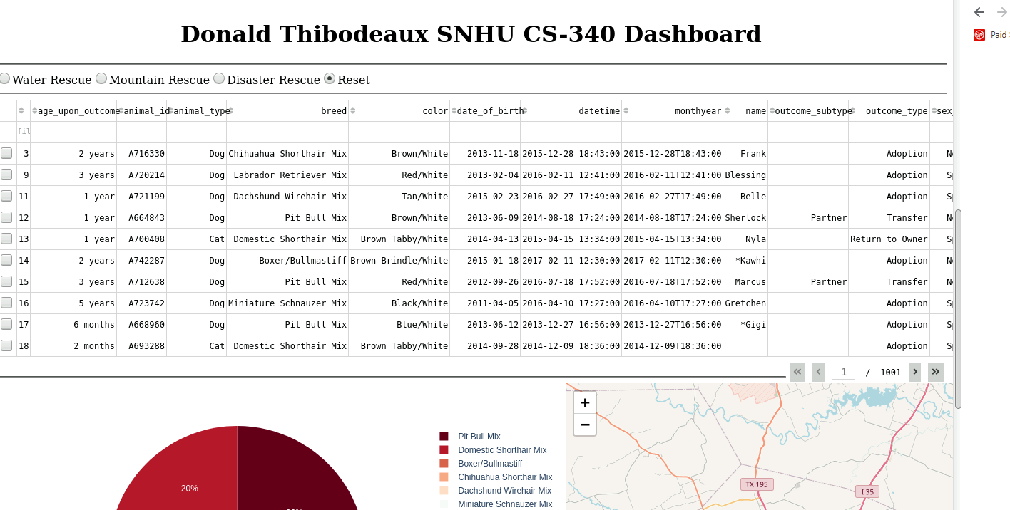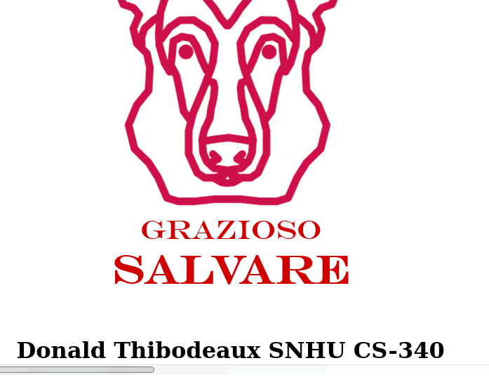

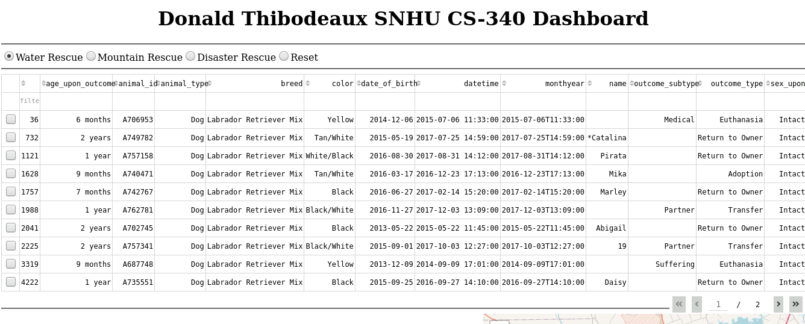

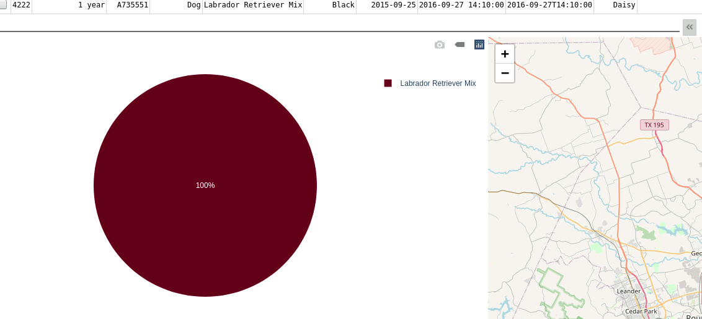

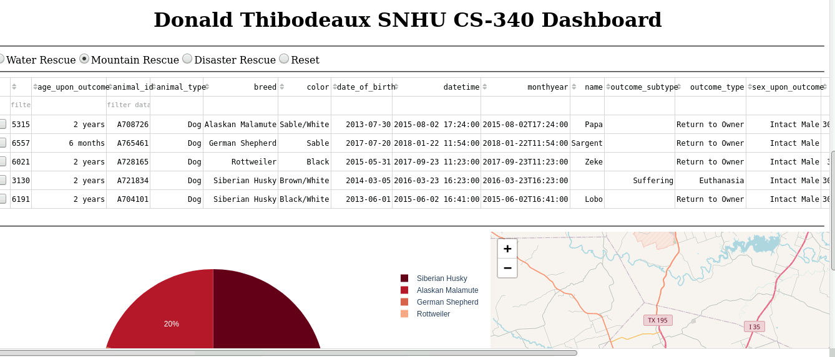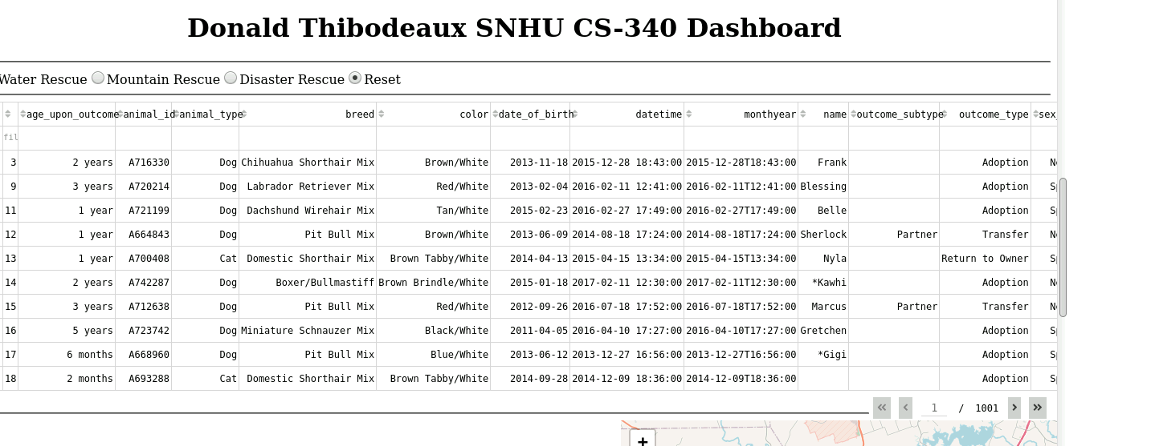

## 

## 

## Challenges

The challenges I cam across in this project were extensive. To begin I tried using the buttons instead of the radio buttons but I encountered problems with the dash filtering the animals. I switch to dcc radio buttons because it seemed like the style went better with the dash and operated correctly. I came across issues with creating the pie and map but the use of my instructors video along with the resource materials and YouTube videos I was able to make them function.

## Contact

Your name: Donald Thibodeaux